**Oldbench.c**

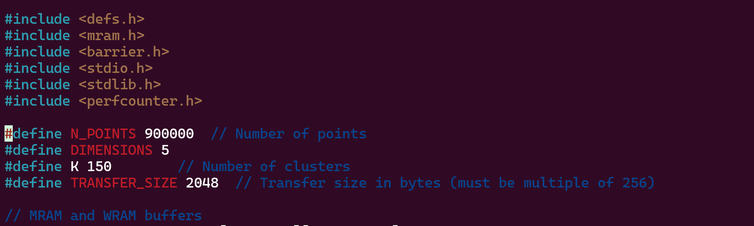

**On Local:**

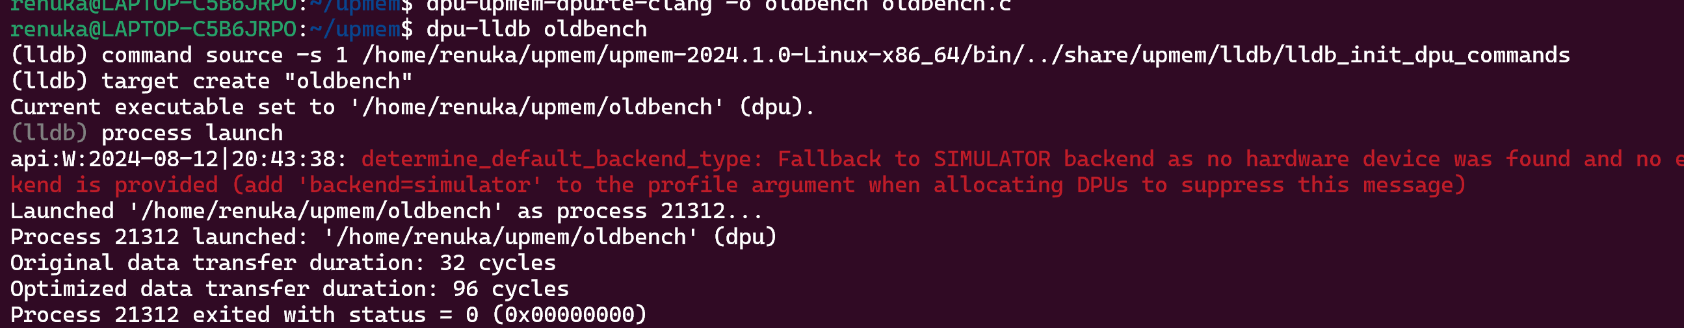

**On Server:**

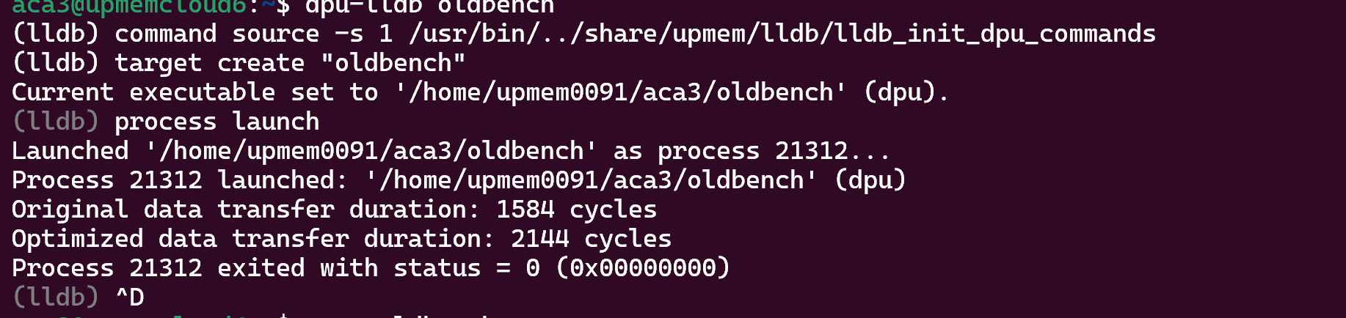

**Second Parameter:**

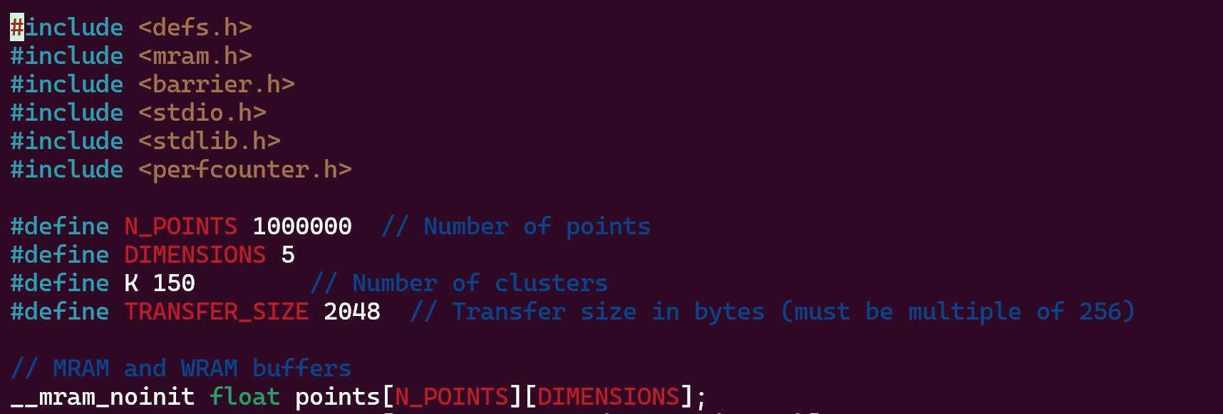

**On local:**

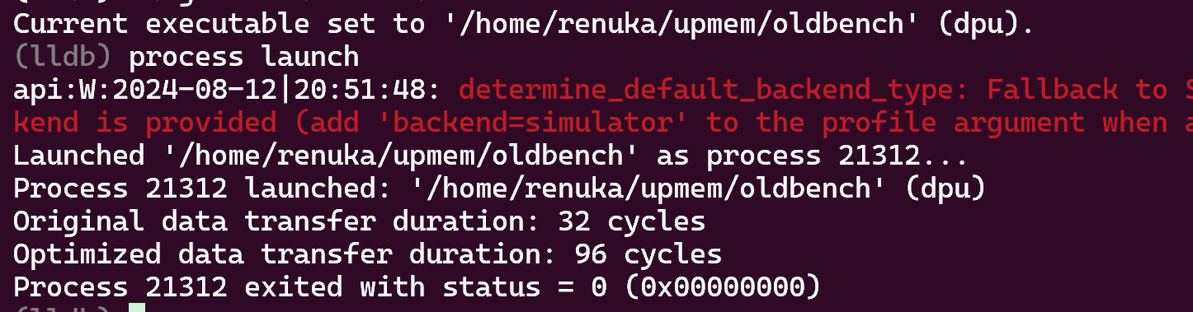

**On server**

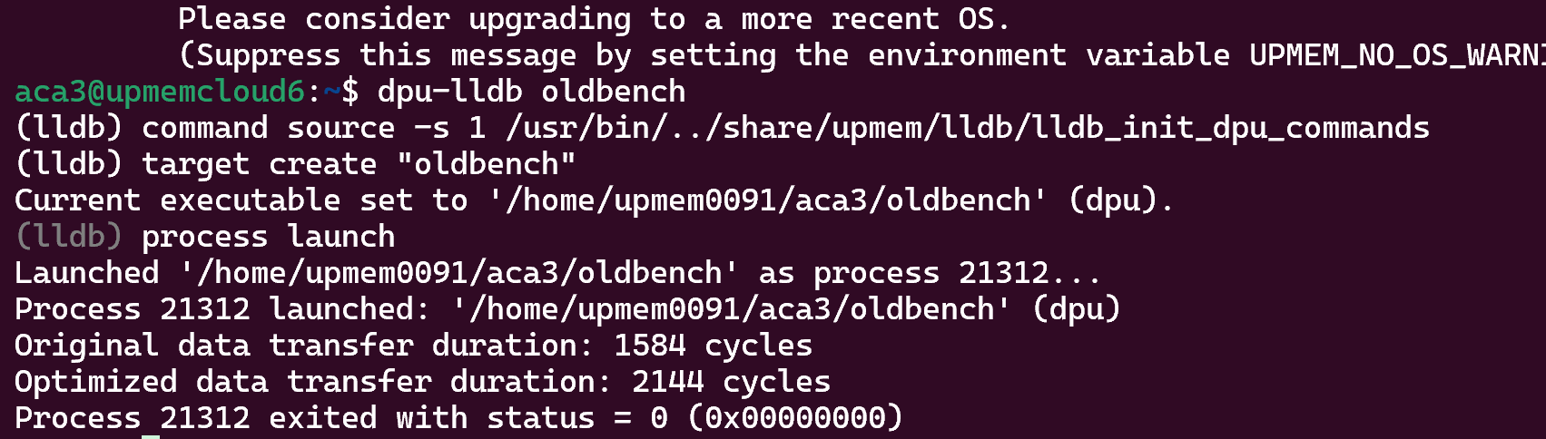

**Third Parameter:**

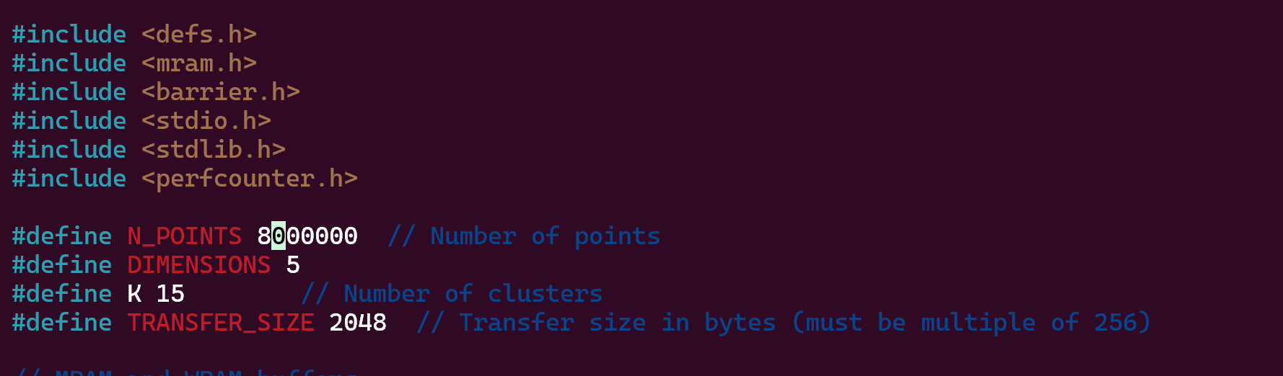

**or** 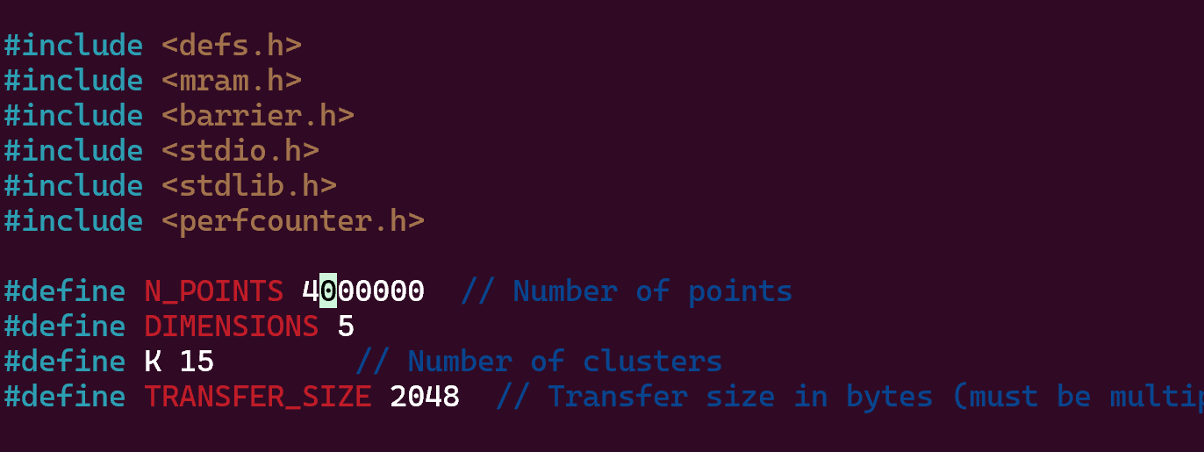

**N_POINTS less than 4000000 is working in server**

**On servver :**

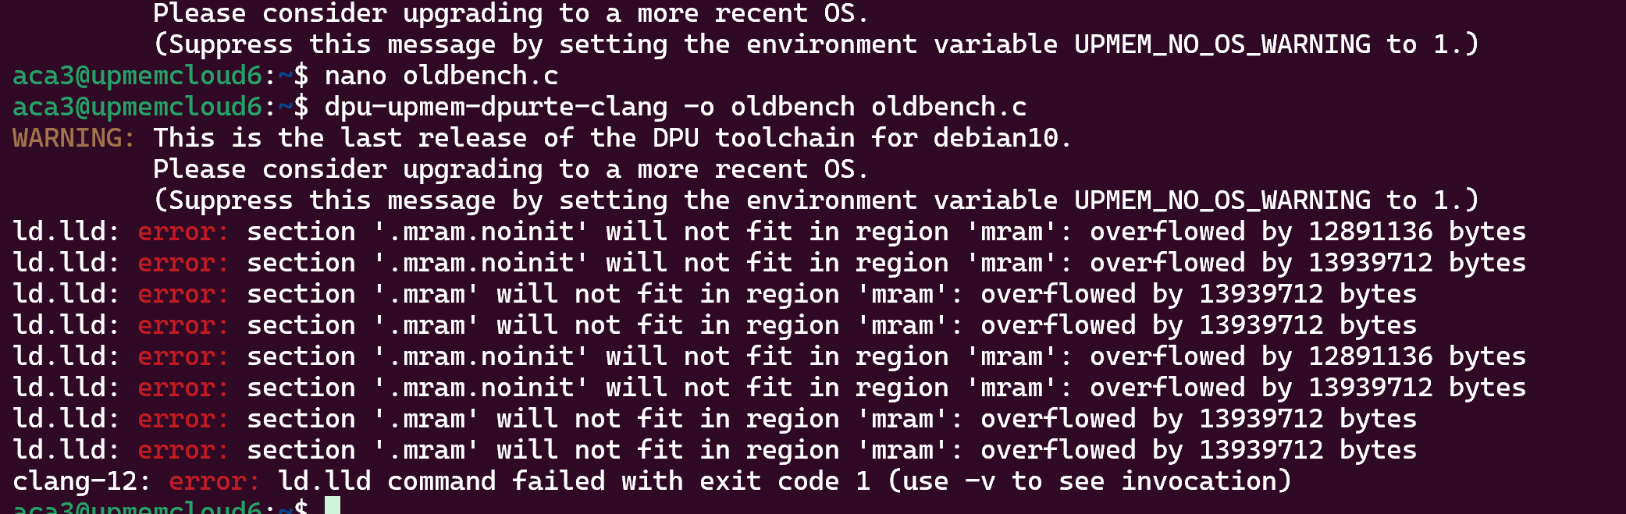

**Same in local:**

**N_POINTS less than 4000000 is working in local also**

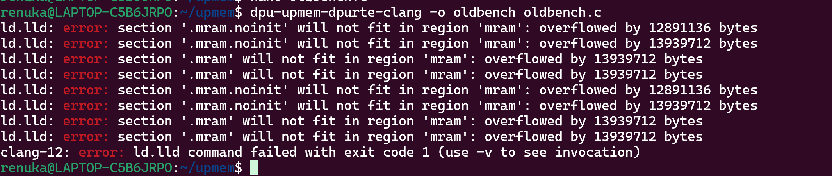

**Fin.c**

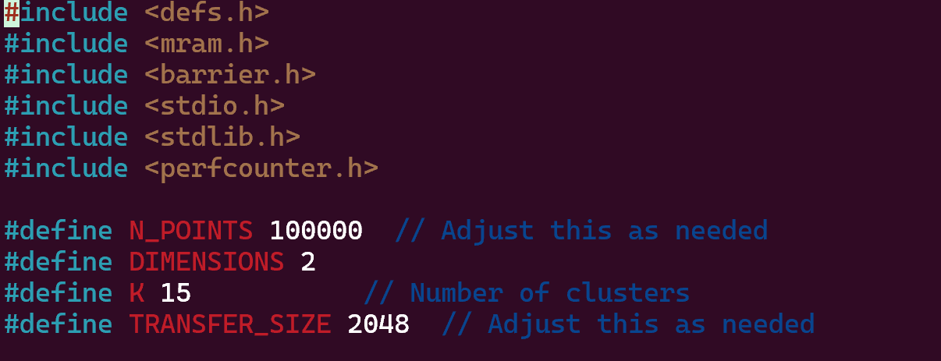

**Local:**

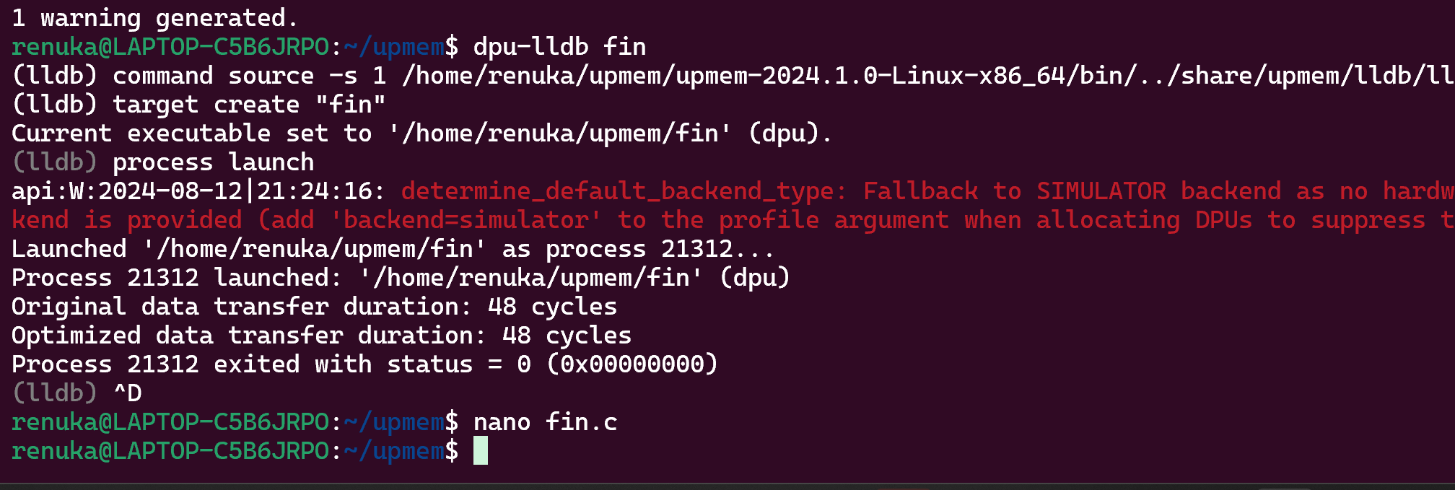

**Server:**

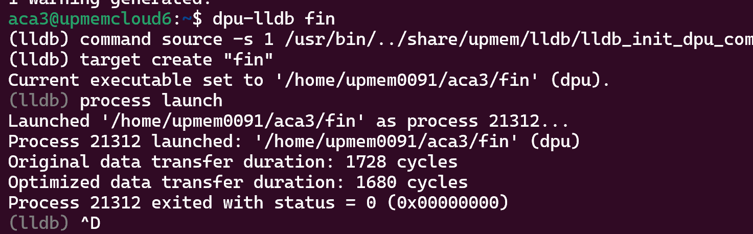

**Second parameter**

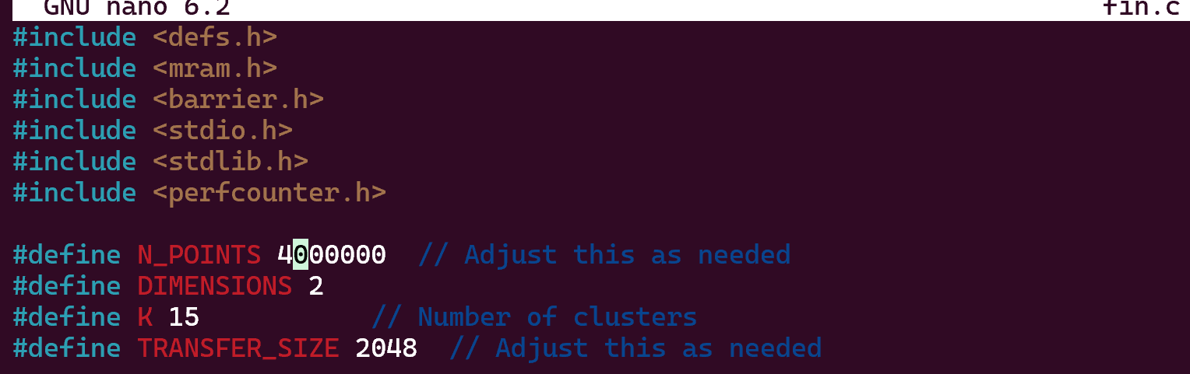

**On Local:**

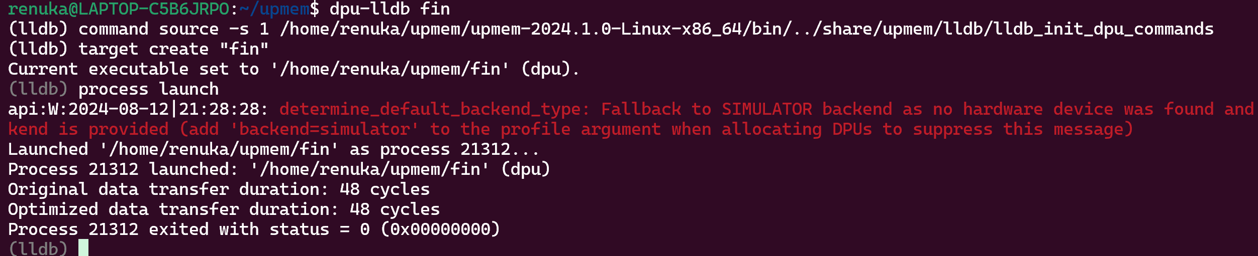

**On server:**

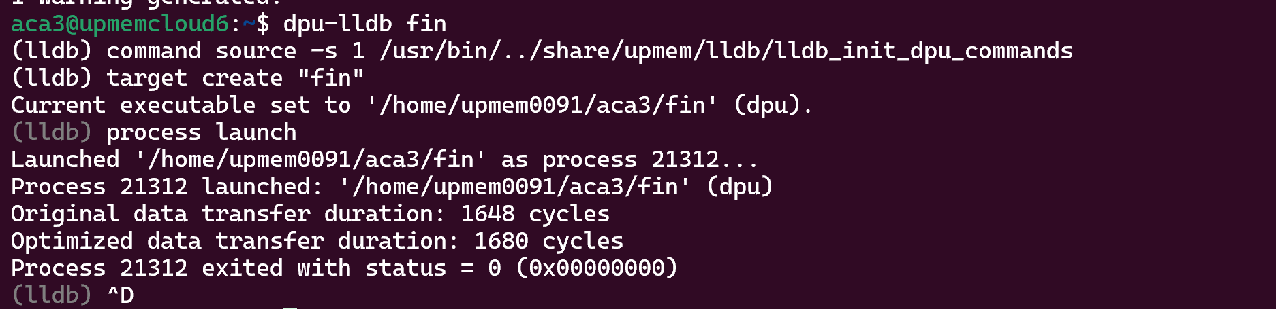

**Finalbench.c**

**Started at 9:15 for server and local both.**

**Server stopped at 9:36**

**Local Stopped at 9:47**

**For Parameter:**

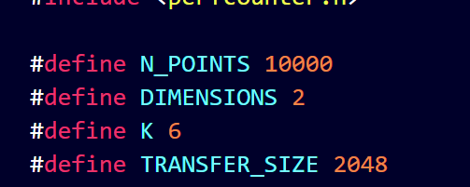

**Server:**

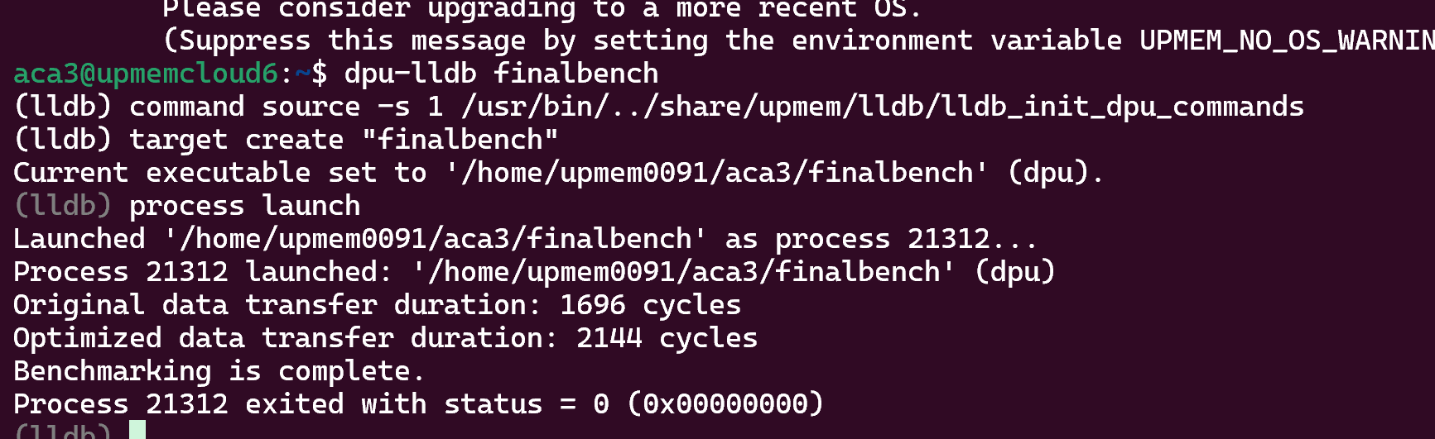

**Local:**

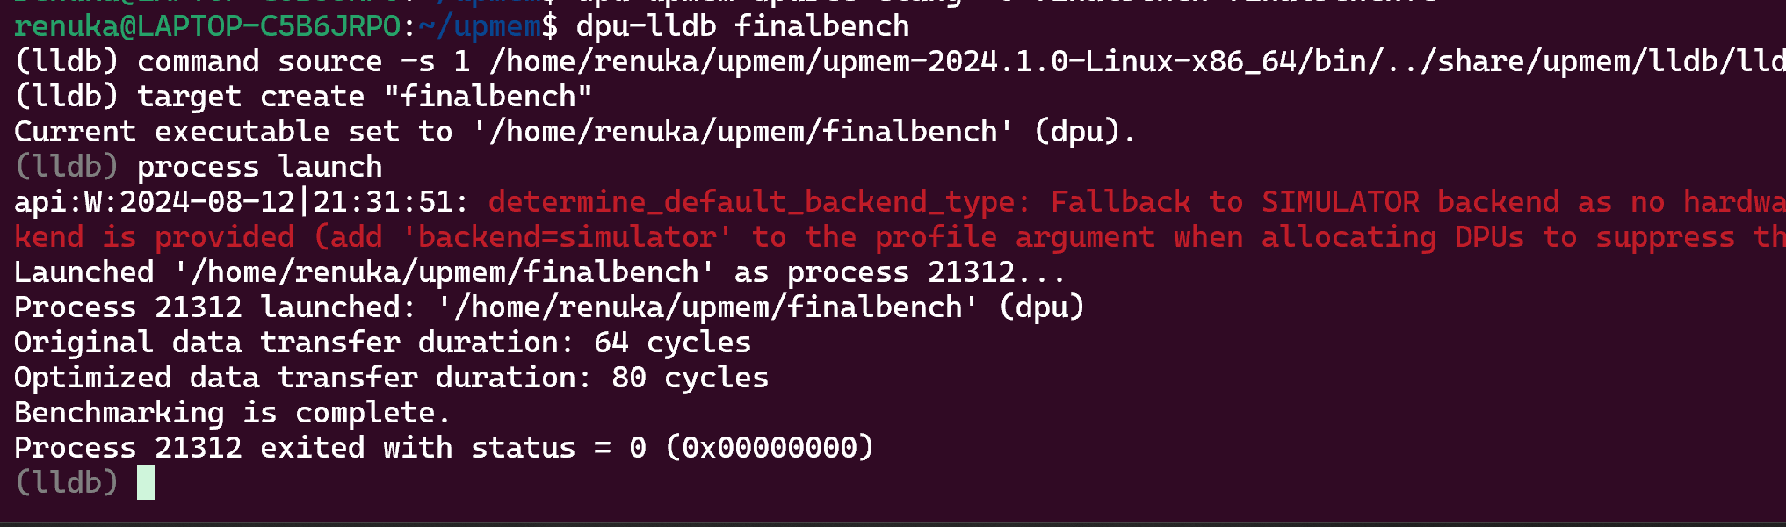

**New parameter**

**Started server : 9:38pm I stopped manually at 11:39pm as it did not finish till time:**

**On local I observed for almost more than 4hours but it did not stopped so it was taking a longer time.**

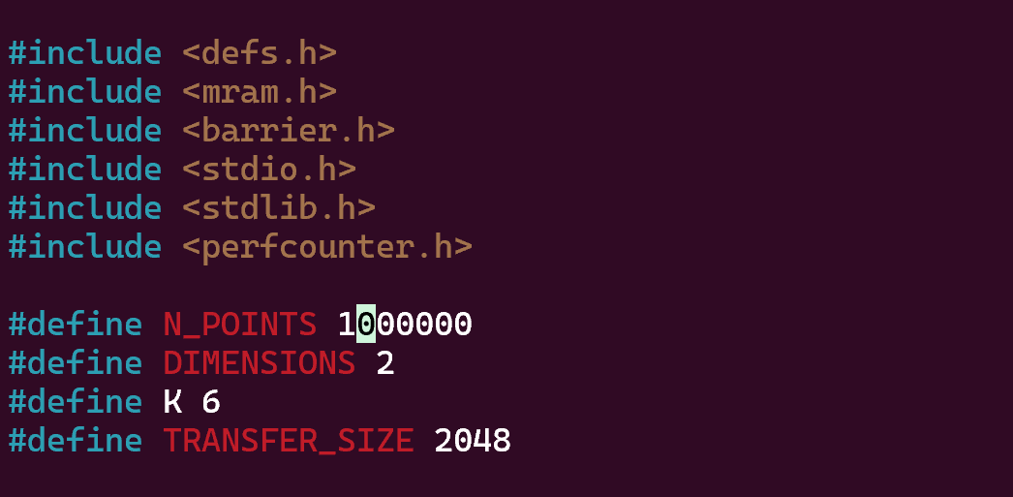

**dpuOptimized.c**

**with 100000 points gives memory fault in local.**

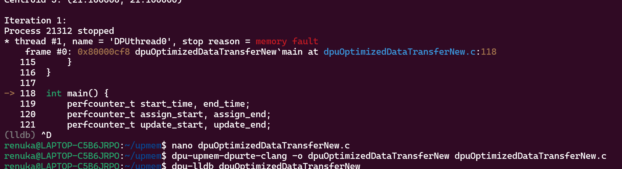

**So I started with 50000 in local started at 10:43 pm**

**Got stopped automatically at 10:50 at local**

